Portfolio assignment Ethics 2 Reinder Weenink

1. “Formulate your first impression on the ethical issues and how they came about”

I'm not sure what you mean by this. But the following happened to Breeze i.m.o.

Breeze developed an app with an algorithm they don’t understand. They are successful with the app “September 2023: Approximately 40,000 weekly active users. (google)”. They do not take regulations properly into account. Some customers start to complain about the lack of diversity of the suggestions made by the app. Breeze doesn’t know how to solve the problem but has to act on this according to regulations. Breeze consults a comity on what to do. The comity applauds them for consulting them. It is unclear if the problem is resolved.

Ethical issues:

1. In my opinion it is an ethical problem that the entrepreneurs of Breeze don't know how the algorithm works and did not foresee this problem. They developed something which does not comply with the regulations.
2. It is also an ethical problem that the comity is actually asked for guidance. It should be a no brainer in my opinion. An algorithm which discriminates simply cannot be.
3. It is an ethical problem that the comity is not directly saying that the app should be taken offline until it is working properly and this is supported by proper investigation. “Dat organisaties als Breeze hiertoe de eerste stappen zetten, juicht het College toe.”. This is completely wrong, the app is violating the law and by decreeing this they give leeway to be discriminative until people complain.

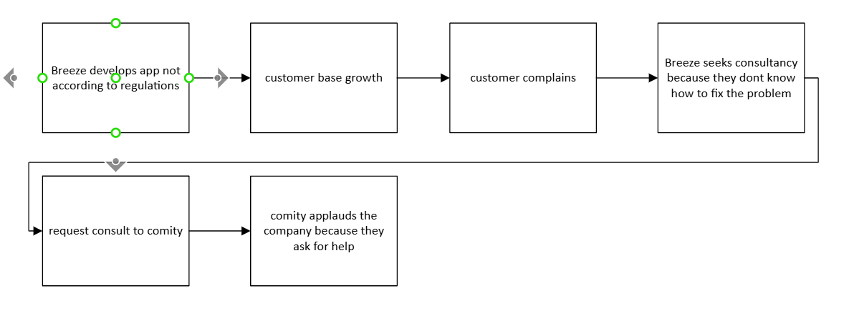

I don't have the feeling I missed points after drawing the DAG. In my opinion it is really poignant that Breeze has received so much leeway from the comity. I would not be surprised if the whole process of consulting the comity is actually done to seem to be clean and wash Breezes hands in innocence.